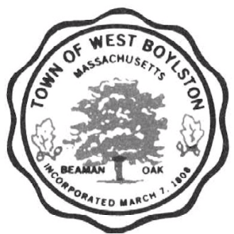
Town of West Boylston
Department of Public Works
35 Worcester Street
West Boylston, MA 01583
508-835-4820

FULL TIME MECHANIC/OPERATOR
WEST BOYLSTON DPW - EOE

West Boylston DPW seeks a full-time Mechanic/Operator to join the Highway Division. MA Class B CDL (with Air Brake Endorsement), and a MA Hydraulic License (Grade 2B), or the ability to obtain the licenses within one year, preferred. Hourly rate is $21.81 to $25.00 based on experience and qualifications.

Applications, and full job description, are available at the DPW office, 35 Worcester Street, West Boylston, MA from 7:00AM to 3:00PM. Contact DPW with any questions at 508-835-4820.

