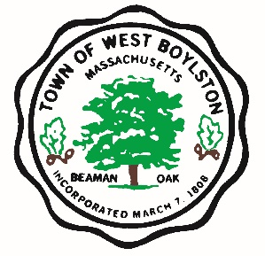

West Boylston Recreational Football Camp Registration Hosted by NGE Sports Performance Center
July 16th 2022, 11:30 am to 1:30 pm Grades 4 – 8 Fee $40

Name: ___________________________________ Childs Name: ________________________________
Address: ___________________________________________________________Phone: ____________
Current Grade _______ Current Football Player Y or N Team: ________________________________
Emergency Contact Other than Parent: _____________________________________________________
Email: _______________________________________________________________________________

Cash or Check (circle one) Make checks payable to the town of West Boylston. Drop off location is Town Hall.

Please sign the liability form attached

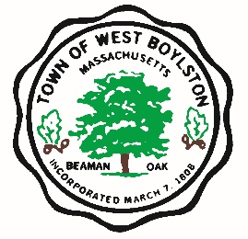

RECREATIONAL AND VOLUNTEERS ACTIVITIES RELEASE FORM

I, the undersigned ___________________, do hereby consent to my participation in voluntary or recreation programs of the Town of West Boylston.

I also agree to forever release the Town of West Boylston, and all their employees, agents, board members, volunteers and any and all individuals and organizations assisting or participating in any voluntary or recreation programs of the Town of West Boylston from any and all claims, rights of action and causes of action that may have arisen in the past, or may arise in the future, directly or indirectly, from personal injuries to myself or property damage resulting from my participation in the Town of West Boylston’s voluntary activities or recreation programs.

I also promise, to indemnify, defend, and hold harmless the Releasees against any and all legal claims and proceedings of any description that may have been asserted in the past, or may be asserted in the future, directly or indirectly, arising from personal injuries to myself or property damage resulting from participation in the Town of West Boylston’s voluntary activities or recreation programs.

I further affirm that I have read this Consent and Release Form and that I understand the contents of this Form. I understand that my participation is voluntary and that I am free to choose not to participate in said programs. By signing this Form, I affirm that I have decided to participate in the Town as a volunteer or in its recreation programs with full knowledge that the Releasees will not be liable to anyone for personal injuries and property damage that I may suffer in voluntary Town activities or recreation programs.

Participant Signature: _____________________________________

Please print name: __________________________________________

Date: _______________

